Name: …………………………………………………………Index No. …………….……………
School: ……………………………………………. Candidate’s Sign. …………..........................
ADM.NO: ……………………………………… Date: ……………............................................

PHYSICS THEORY
PAPER 1
232/1

JULY 2026
TIME: 2 HOURS

ARISE AND SHINE EXAMINATION
FORM FOUR TRIAL 2 TERM 2 2026
Kenya Certificate of Secondary Education (KCSE)

Instructions to the candidates:
- Write your name, admission number and class in the spaces provided above
- Sign and write the date of examination in the spaces provided above
- This paper consist of two Section A and B
- Answer all questions in section A and B in the spaces provided
- All working must be clearly shown where necessary
- Mathematical tables and silent non-programmable calculators may be used.
- Non-programmable silent electronic calculators and KNEC mathematical tables may be used
- Candidates should check the question paper to ascertain that all the pages are printed as indicated and that no questions are missing

For Examiners’ Use Only
SECTION | QUESTION | MAXIMUM SCORE | CANDIDATE’S SCORE
A | 1-12 | 25
B | 13 | 12
B | 14 | 12
B | 15 | 9
B | 16 | 10
B | 17 | 12
B | TOTAL | 80

SECTION A (25 MARKS)
Answer All Questions in This Section in the Spaces Provided
SECTION A 25 MARKS)
Answer all the questions in this section in the spaces provided

1. Figure 1 shows a section of un-graduated Vernier calipers.

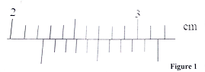
State the reading as indicated by the scale (1 mark)
………………………………………………………………………………………………………………………………………………………………………………………………………………………………
2. Explain why a person would jump higher on earth than on Saturn. (2 marks)
………………………………………………………………………………………………………………………………………………………………………………………………………………………………
………………………………………………………………………………………………………………
3. A mercury thermometer with its fixed points incorrectly marked has the reading of pure melting ice as -0.5ºC and of steam at standard atmospheric pressure as 99.4ºC. Calculate the correct temperature when the thermometer reads 60ºC (2 marks)
………………………………………………………………………………………………………………………………………………………………………………………………………………………………
……………………………………………………………………………………………………………..
4. State two ways the surface tension of a liquid may be increased. (2 marks)
………………………………………………………………………………………………………………………………………………………………………………………………………………………………
5. Figure 2 shows a three identical springs and have negligible weights. Theextension produced on the system of the spring is 40cm.
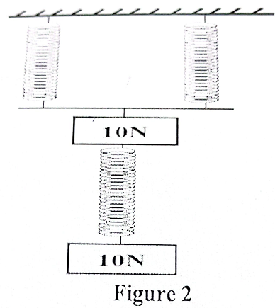

Determine the spring constant of each spring. (2 marks)
………………………………………………………………………………………………………………………………………………………………………………………………………………………………………………………………………………………………………………………………………………6. An oil drop of radius 0.35mm when placed on water spreads out to form a circle of radius 35cm. using this information
- Estimate the size of the oil molecules. (2 marks)
………………………………………………………………………………………………………………………………………………………………………………………………………………………………………………………………………………………………………………………………………………
- State any one assumption you made during your calculation. (1 mark)
………………………………………………………………………………………………………………………………………………………………………………………………………………………………………………………………………………………………………………………………………………
7. Figure 3 is a wooden sphere with a nail hammered into it at a point A as shown below

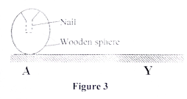
The sphere is rolled on a horizontal ground and comes to rest after some time at point Y. On the same figure 3 draw the sphere after it comes to rest at point Y and explain. (2 marks)
……………………………………………………………………………………………………………………………………………………………………………………………………………………………………………………………………………………………………………………………………………..
8. In Figure 4 below, a pipe with two different cross-sectional areas has two pipes dipped into its walls at the points of different cross-section areas. The pipes A and B are identical in cross sectional areas.
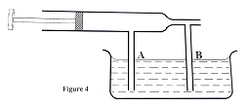

Show the new level of water in column A and B when the piston is pulled back. (1 mark)
………………………………………………………………………………………………………………………………………………………………………………………………………………………………
9. A student performed an experiment find out how the length L of a spiral spring varies with the compression force, F, Figure 5 shows the results obtained.
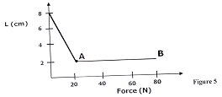
State a reason for the shape of the graph between 20N and 80N (1 mark)
………………………………………………………………………………………………………………………………………………………………………………………………………………………………………………………………………………………………………………………………………………………………………………………………………………………………………………………………………………………………………………………………………………………………………………
10. A string of length 0.7m is used to whirl a stone of mass 500g in a circle in a vertical plane at 5 rev/s. Determine:
(a) The period (2 marks)
………………………………………………………………………………………………………………………………………………………………………………………………………………………………………………………………………………………………………………………………………………
(b) The angular velocity. (3 marks)
………………………………………………………………………………………………………………………………………………………………………………………………………………………………………………………………………………………………………………………………………………
11. Figure 6 shows a uniform meter rule of Weight 2N with two weights 0.36N and 0.24N suspended from its ends.
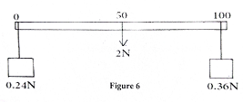

Determine how far from the 0.36N weight a pivot should be placed in order to balance the meter rule. (3 marks)
………………………………………………………………………………………………………………………………………………………………………………………………………………………………………………………………………………………………………………………………………………
12. State a reason why water is not suitable as a barometric liquid. (1 mark)
………………………………………………………………………………………………………………………………………………………………………………………………………………………………
SECTION B (55 MARKS)
Answer ALL questions in the spaces provided.

13. (a). Figure 7 below shows a set-up that may be used to verify pressure law.
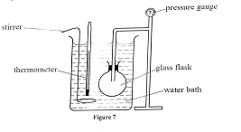
- State the measurements that should be taken in the experiment. (2 marks)
………………………………………………………………………………………………………………………………………………………………………………………………………………………………
……………………………………………………………………………………………………………..
- Explain how the measurements in(i) above may be used to verify pressure law (3 marks)
………………………………………………………………………………………………………………………………………………………………………………………………………………………………
……………………………………………………………………………………………………………..
………………………………………………………………………………………………………………
(b) A column of air 26cm long is trapped by mercury thread 5.0cm long as shown in the Figure 8(a) below
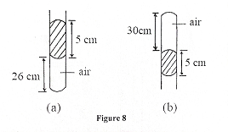
When the tube is inverted as in Figure 8(b) the air column becomes 30cm long. What is the value of atmospheric pressure? (3 marks)
………………………………………………………………………………………………………………………………………………………………………………………………………………………………………………………………………………………………………………………………………………
………………………………………………………………………………………………………………
(c). A steel cylinder of capacity 0.5m³ contains nitrogen at a pressure of 30,000Pa when the temperature is 27ºC. What will be the pressure of nitrogen if it is allowed to flow into another cylinder of capacity 9.5m³ with the temperature reduced to -23ºC? (3 marks)
………………………………………………………………………………………………………………………………………………………………………………………………………………………………………………………………………………………………………………………………………………
(d). State the difference between the temperature in Kelvin scale and Celsius scale. (1 mark)
………………………………………………………………………………………………………………
……………………………………………………………………………………………………………..
14.(a). Figure 9 shows a block A immersed in water. It weighs 2N in air and has a density of 2.0g/cm³. If the bar is pivoted at its center and is in equilibrium find the distance x(p of water 1g/cm³) (3 mark)
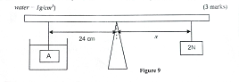
………………………………………………………………………………………………………………………………………………………………………………………………………………………………
……………………………………………………………………………………………………………..
(b). Figure 10 below shows a wooden log 1ocm log, density 800kg/m³ and cross-sectional area 0.06m² floating in water of density 1g/cm³ while partially submerged
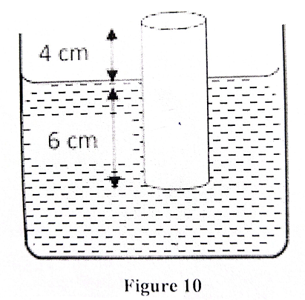

(i) Determine the weight of the block. (3 marks)
……………………………………………………………………………………………………………..
………………………………………………………………………………………………………………………………………………………………………………………………………………………………
……………………………………………………………………………………………………………..
(ii) The upthrust on the block. (3 marks)
……………………………………………………………………………………………………………..
………………………………………………………………………………………………………………………………………………………………………………………………………………………………
……………………………………………………………………………………………………………..
(iii) The minimum weight that can be placed on the block to just make it fully submerged. (3 marks)
……………………………………………………………………………………………………………..
………………………………………………………………………………………………………………………………………………………………………………………………………………………………
……………………………………………………………………………………………………………..
15. (a) A man used a wooden plank to lift a wooden log from the ground to a stationary truck as shown in Figure 11. The wooden plank is inclined at an angle of 30º to the ground. (3 marks)
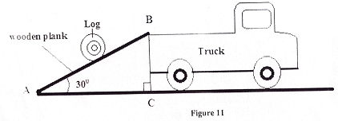
- Show that the velocity ratio of the system is stated as V.R = $\frac{1}{{\sin{30}}^{o}}$ (3 marks)
………………………………………………………………………………………………………………………………………………………………………………………………………………………………………………………………………………………………………………………………………………………………………………………………………………………………………………………………
(ii). Explain why the efficiency of this system cannot be 100%. (1 mark)
………………………………………………………………………………………………………………………………………………………………………………………………………………………………………………………………………………………………………………………………………………………………………………………………………………………………………………………………
(b). Figure 12 shows a pulley system
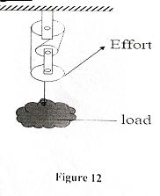
(i) State the velocity ratio of the machine (1 mark)
…………………………………………………………………………………………………………..
(ii) Explain what happens to the mechanical advantage of the machine as the load is increased gradually. (1 mark)
………………………………………………………………………………………………………………………………………………………………………………………………………………………………
(c) Water falls from a water fall to the bottom. The temperature of the water is found to be higher at the bottom than at the top. State the energy transformation. (1 mark)
………………………………………………………………………………………………………………………………………………………………………………………………………………………………
(d) An automated warehouse robot is pulling a 10kg crate across a wooden load dock of co-efficient of friction 0.04: The motor exerts a constant tension. To optimize the robot’s battery, the engineering team needs to account for energy loss to friction. Calculate the force of friction resisting the robot’s pull. (2 marks)
………………………………………………………………………………………………………………………………………………………………………………………………………………………………
………………………………………………………………………………………………………………………………………………………………………………………………………………………………
16. A boy stands at the top of a cliff of height,h, above the ground and throws a ball vertically upwards. The variation of time t and velocity v of the ball is shown in Figure 13
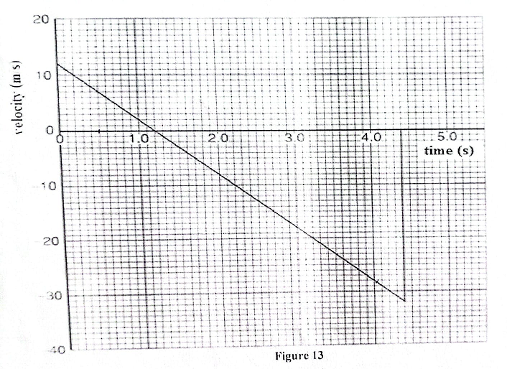

Use graph above to determine;
- Time taken to reach the maximum height. (1 mark)
…………………………………………………………………………………………………………..

(b) Time taken from the maximum height to the ground below the cliff. (1 mark)
…………………………………………………………………………………………………………………………………………………………………………………………………………………………….
(c) Determine the maximum height above the base of the cliff to which the ball rises. (3 marks)
………………………………………………………………………………………………………………………………………………………………………………………………………………………………………………………………………………………………………………………………………………
……………………………………………………………………………………………………………
(d) The value of h, height of the ball before projection. (2 marks)
………………………………………………………………………………………………………………………………………………………………………………………………………………………………………………………………………………………………………………………………………………
(e) The ball has mass 250g. Calculate the magnitude of the change in momentum of the ball between the time that it leaves the girl’s hand to tie t = 4.0s. (3 marks)
………………………………………………………………………………………………………………………………………………………………………………………………………………………………………………………………………………………………………………………………………………
……………………………………………………………………………………………………………

(17) (a) The moon goes round the earth at a constant speed. Explain why it is true to say the moon is accelerating. (1 mark)
………………………………………………………………………………………………………………………………………………………………………………………………………………………………………………………………………………………………………………………………………………
(b). Figure 14 below shows a pail of water being swung in a vertical circle
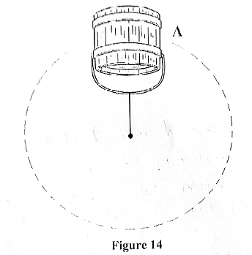

Explain why the water does not pour out when the pail is at position A. (1 mark)
………………………………………………………………………………………………………………………………………………………………………………………………………………………………
(c) A string of negligible mass has a bucket tied at the end. The string is 60cm long and the bucket has a mass of 45g. The bucket is swung horizontally making 6 revolutions per second. Calculate:
(i) The angular velocity (2 marks)
………………………………………………………………………………………………………………………………………………………………………………………………………………………………

- The angular acceleration. (3 marks)
………………………………………………………………………………………………………………
……………………………………………………………………………………………………………
………………………………………………………………………………………………………………

(iii) The tension on the string (3 marks)
………………………………………………………………………………………………………………………………………………………………………………………………………………………………………………………………………………………………………………………………………………
(iv). The linear velocity (2 marks)
………………………………………………………………………………………………………………………………………………………………………………………………………………………………………………………………………………………………………………………………………………

